**Sprint Review 3**

On 11 October 2022, we met Mr Michael De Dervalho, the customer, for a sprint 3 review meeting. The main was to show him what we have done this sprint. His main focus was to make sure that when a user posts, a picture, other users can comment and like the picture. All the users should be able to see the number of followers they have. In addition, he wanted the app to count of the number of comments and likes which we managed to do.

**Post texts**

In this screenshot attached, the user can now post text messages and other users can respond, like and comment on the text. This feature gives users extra flexibility to have more things to post and get to chat about in the app.

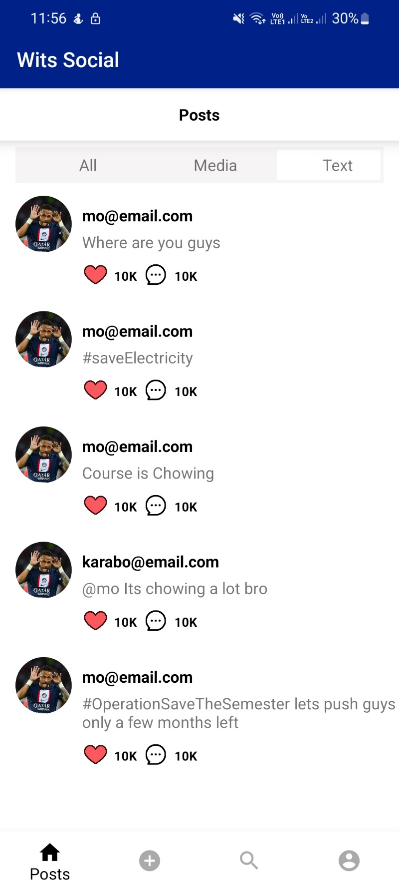

**Liking pictures**

Exciting news!! The users can now like a post and view a number of likes a posts they have. This is an exciting feature as users can now see who is more influential and who posts the most likable pictures.

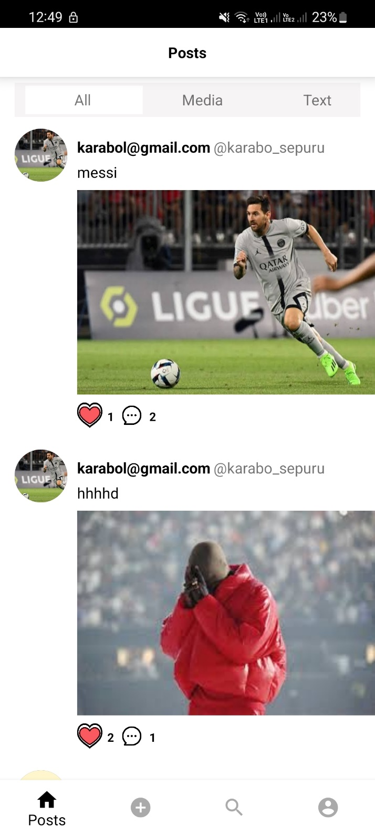

**Adding comments**

Ever wondered what people think about your post and pictures? Do not stress yourself out, the users can now comment on pictures and texts. Mr Michael was really impressed by this feature because it worked exactly as he wanted it to.

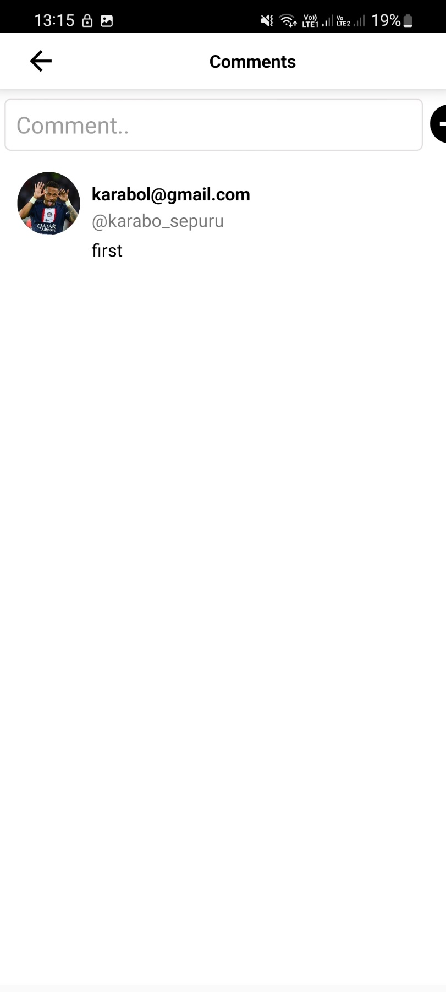

**Add profile picture**

In the previous version of the app, all the users had the same profile picture which is unfair for everyone’s profile to look identical. We added a feature that allows a user to upload their own picture of choice. This pictures includes different users with different profiles pictures

